Computer Network and Data Communication
UNIT 2
Data Transmission
The successful transmission of data depends principally on two factors: the quality of the signal being transmitted and the characteristics of the transmission medium. The objective of this chapter and the next is to provide the reader with an intuitive feeling for the nature of these two factors.
The first section presents some concepts and terms from the field of electrical engineering. This should provide sufficient background to deal with the remainder of the chapter. Section 3.2 clarifies the use of the terms analog and digital. Either analog or digital data may be transmitted using either analog or digital signals. Furthermore, it is common for intermediate processing to be performed between source and destination, and this processing has either an analog or digital character.
Section 3.3 looks at the various impairments that may introduce errors into the data during transmission. The chief impairments are attenuation, attenuation distortion, delay distortion, and the various forms of noise. Finally, we look at the important concept of channel capacity.
Concepts and Terminology
In this section, we introduce some concepts and terms that will be referred to throughout the rest of the chapter and, indeed, throughout Part Two.
Transmission Terminology
Data transmission occurs between transmitter and receiver over some transmission medium. Transmission media may be classified as guided or unguided. In both cases, communication is in the form of electromagnetic waves. With guided media, the waves are guided along a physical path; examples of guided media are twisted pair, coaxial cable, and optical fiber. Unguided media, also called wireless, provide a means for transmitting electromagnetic waves but do not guide them; examples are propagation through air, vacuum, and seawater.
The term direct link is used to refer to the transmission path between two devices in which signals propagate directly from transmitter to receiver with no intermediate devices, other than amplifiers or repeaters used to increase signal strength. Note that this term can apply to both guided and unguided media.
A guided transmission medium is point to point if it provides a direct link between two devices and those are the only two devices sharing the medium. In a multipoint guided configuration, more than two devices share the same medium.
A transmission may be simplex, half duplex, or full duplex. In simplex transmission, signals are transmitted in only one direction; one station is transmitter and the other is receiver. In half-duplex operation, both stations may transmit, but only one at a time. In full-duplex operation, both stations may transmit simultaneously. In the latter case, the medium is carrying signals in both directions at the same time. We should note that the definitions just given are the ones in common use in the United States (ANSI definitions). Elsewhere (ITU-T definitions), the term simplex is used to correspond to half duplex, and duplex is used to correspond to full duplex as just defined.
Analog and Digital Data Transmission
The terms analog and digital correspond, roughly, to continuous and discrete, respectively. These two terms are used frequently in data communications in at least three contexts: data, signaling, and transmission.
Briefly, we define data as entities that convey meaning, or information. Signals are electric or electromagnetic representations of data. Signaling is the physical propagation of the signal along a suitable medium. Transmission is the communication of data by the propagation and processing of signals. In what follows, we try to make these abstract concepts clear by discussing the terms analog and digital as applied to data, signals, and transmission.

Transmission Impairments
With any communications system, the signal that is received may differ from the signal that is transmitted, due to various transmission impairments. For analog signals, these impairments introduce various random modifications that degrade the signal quality. For digital signals, bit errors may be introduced, such that a binary 1 is transformed into a binary 0 or vice versa. In this section, we examine the various impairments and how they may affect the information-carrying capacity of a communication link; Chapter 5 looks at measures that can be taken to compensate for these impairments.
The most significant impairments are:
• Attenuation and attenuation distortion.
• Delay distortion.
• Noise.
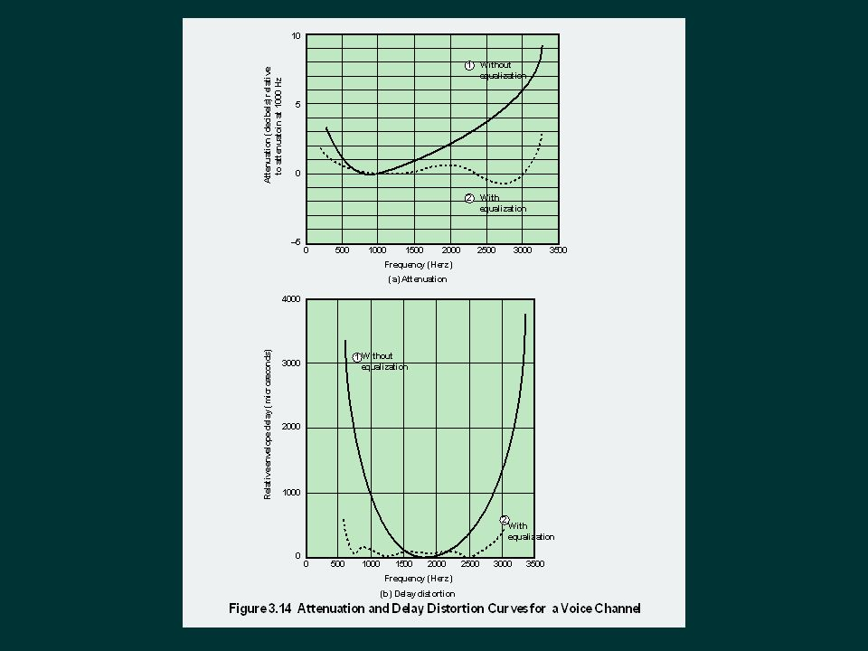

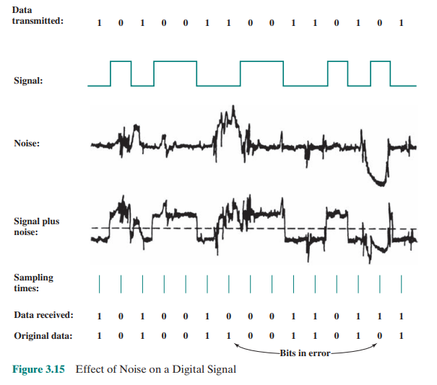
Channel Capacity:
We have seen that there are a variety of impairments that distort or corrupt a signal. For digital data, the question that then arises is to what extent these impairments limit the data rate that can be achieved. The maximum rate at which data can be transmitted over a given communication path, or channel, under given conditions, is referred to as the channel capacity. There are four concepts here that we are trying to relate to one another.
• Data rate: The rate, in bits per second (bps), at which data can be communicated
• Bandwidth: The bandwidth of the transmitted signal as constrained by the transmitter and the nature of the transmission medium, expressed in cycles per second, or hertz
• Noise: The average level of noise over the communications path
• Error rate: The rate at which errors occur, where an error is the reception of a 1 when a 0 was transmitted or the reception of a 0 when a 1 was transmitted
The problem we are addressing is this: Communications facilities are expensive, and, in general, the greater the bandwidth of a facility, the greater the cost. Furthermore, all transmission channels of any practical interest are of limited bandwidth. The limitations arise from the physical properties of the transmission medium or from deliberate limitations at the transmitter on the bandwidth to prevent interference from other sources. Accordingly, we would like to make as efficient use as possible of a given bandwidth. For digital data, this means that we would like to get as high a data rate as possible at a particular limit of error rate for a given bandwidth. The main constraint on achieving this efficiency is noise.
Transmission medium
In a data transmission system, the transmission medium is the physical path between transmitter and receiver. Recall from Chapter 3 that for guided media, electromagnetic waves are guided along a solid medium, such as copper twisted pair, copper coaxial cable, and optical fiber. For unguided media, wireless transmission occurs through the atmosphere, outer space, or water.
The characteristics and quality of a data transmission are determined both by the characteristics of the medium and by the characteristics of the signal. In the case of guided media, the medium itself is more important in determining the limitations of transmission.
For unguided media, the bandwidth of the signal produced by the transmitting antenna is more important than the medium in determining transmission characteristics. One key property of signals transmitted by antenna is directionality. In general, signals at lower frequencies are omnidirectional; that is, the signal propagates in all directions from the antenna. At higher frequencies, it is possible to focus the signal into a directional beam.
Data rate and distance are the key considerations in data transmission system design, with emphasis placed on achieving the highest data rates over the longest distances. A number of design factors relating to the transmission medium and the signal determine the data rate and distance:
• Bandwidth: All other factors remaining constant, the greater the bandwidth of a signal, the higher the data rate that can be achieved.
• Transmission impairments: Impairments, such as attenuation, limit the distance. For guided media, twisted pair generally suffers more impairment than coaxial cable, which in turn suffers more than optical fiber.
• Interference: Interference from competing signals in overlapping frequency bands can distort or cancel out a signal. Interference is of particular concern for unguided media, but is also a problem with guided media. For guided media, interference can be caused by emanations from nearby cables (alien crosstalk) or adjacent conductors under the same cable sheath (internal crosstalk). For example, twisted pairs are often bundled together and conduits often carry multiple cables. Interference can also be caused by electromagnetic coupling from unguided transmissions. Proper shielding of a guided medium can minimize this problem.
• Number of receivers: A guided medium can be used to construct a pointto-point link or a shared link with multiple attachments. In the latter case, each attachment introduces some attenuation and distortion on the line, limiting distance and/or data rate.
Figure 4.1 depicts the electromagnetic spectrum and indicates the frequencies at which various guided media and unguided transmission techniques operate. In this chapter, we examine these guided and unguided alternatives. In all cases, we describe the systems physically, briefly discuss applications, and summarize key transmission characteristics.
Guided Transmission Media
For guided transmission media, the transmission capacity, in terms of either data rate or bandwidth, depends critically on the distance and on whether the medium is point-to-point or multipoint. Table 4.1 indicates the characteristics typical for the common guided media for long-distance point-to-point applications; we defer a discussion of the use of these media for local area networks (LANs) to Part Four.
The three guided media commonly used for data transmission are twisted pair, coaxial cable, and optical fiber (Figure 4.2). We examine each of these in turn. 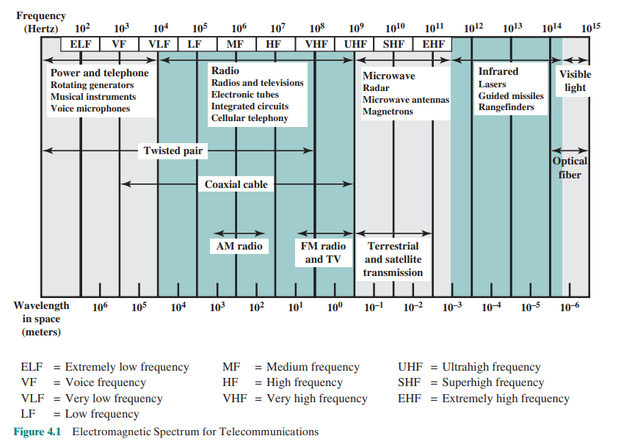
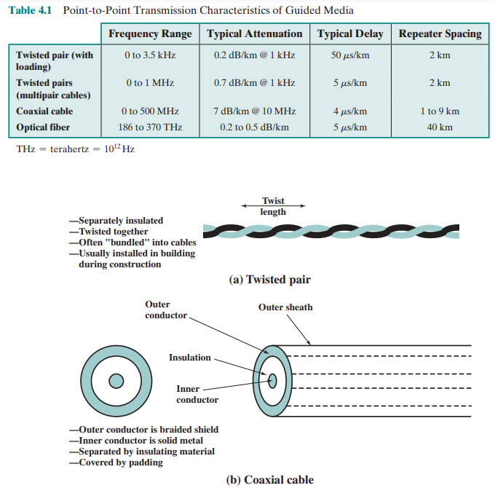
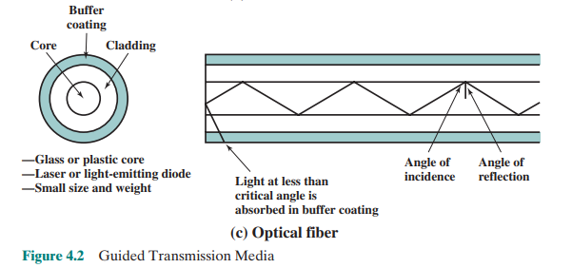

Wireless Transmission:
Three general ranges of frequencies are of interest in our discussion of wireless transmission. Frequencies in the range of about 1 GHz (gigahertz = 109 hertz) to 40 GHz are referred to as microwave frequencies. At these frequencies, highly directional beams are possible, and microwave is quite suitable for point-to-point transmission. Microwave is also used for satellite communications. Frequencies in the range of 30 MHz to 1 GHz are suitable for omnidirectional applications. We refer to this range as the radio range.
Another important frequency range, for local applications, is the infrared portion of the spectrum. This covers, roughly, from 3 * 1011 to 2 * 1014Hz. Infrared is useful to local point-to-point and multipoint applications within confined areas, such as a single room.
For unguided media, transmission and reception are achieved by means of an antenna. Before looking at specific categories of wireless transmission, we provide a brief introduction to antennas.
Antennas
An antenna can be defined as an electrical conductor or system of conductors used either for radiating electromagnetic energy or for collecting electromagnetic energy. For transmission of a signal, radio-frequency electrical energy from the transmitter is converted into electromagnetic energy by the antenna and radiated into the surrounding environment (atmosphere, space, water). Reception occurs when the electromagnetic signal intersects the antenna, where the electromagnetic energy is converted into radio-frequency electrical energy and fed into the receiver.
In two-way communication, the same antenna can be and often is used for both transmission and reception. This is possible because any antenna transfers energy from the surrounding environment to its input receiver terminals with the same efficiency that it transfers energy from the output transmitter terminals into the surrounding environment, assuming that the same frequency is used in both directions. Put another way, antenna characteristics are essentially the same whether an antenna is sending or receiving electromagnetic energy.
An antenna radiates power in all directions but, typically, does not perform equally well in all directions. A common way to characterize the performance of an antenna is the radiation pattern, which is a graphical representation of the radiation properties of an antenna as a function of space coordinates. The simplest pattern is produced by an idealized antenna known as the isotropic antenna. An isotropic antenna, also called an omnidirectional antenna, is a point in space that radiates power in all directions equally. The actual radiation pattern for the isotropic antenna is a sphere with the antenna at the center.
Wireless Propagation
A signal radiated from an antenna travels along one of three routes: ground wave, sky wave, or line of sight (LOS). Table 4.5 shows in which frequency range each predominates. In this book, we are almost exclusively concerned with LOS communication, but a short overview of each mode is given in this section.

Ground Wave Propagation
Ground wave propagation (Figure 4.11a) more or less follows the contour of the Earth and can propagate considerable distances, well over the visual horizon. This effect is found in frequencies up to about 2 MHz. Several factors account for the tendency of electromagnetic wave in this frequency band to follow the Earth’s curvature. One factor is that the electromagnetic wave induces a current in the Earth’s surface, the result of which is to slow the wavefront near the Earth, causing the wavefront to tilt downward and hence follow the Earth’s curvature. Another factor

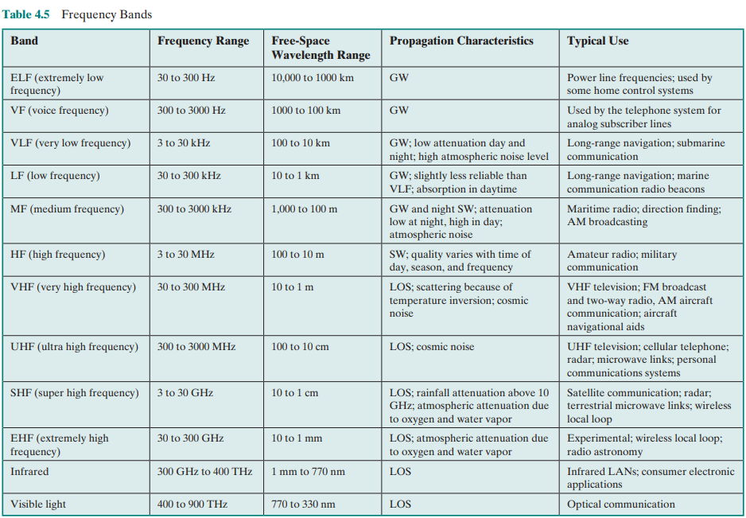
is diffraction, which is a phenomenon having to do with the behavior of electromagnetic waves in the presence of obstacles. Electromagnetic waves in this frequency range are scattered by the atmosphere in such a way that they do not penetrate the upper atmosphere. The best-known example of ground wave communication is AM radio.

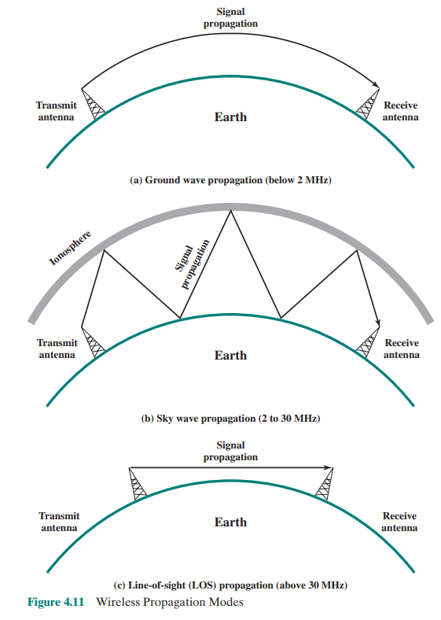
Sky Wave Propagation
Sky wave propagation is used for amateur radio and international broadcasts such as BBC and Voice of America. With sky wave propagation, a signal from an earth-based antenna is reflected from the ionized layer of the upper atmosphere (ionosphere) back down to Earth. Although it appears the wave is reflected from the ionosphere as if the ionosphere were a hard reflecting surface, the effect is in fact caused by refraction. Refraction is described subsequently.
A sky wave signal can travel through a number of hops, bouncing back and forth between the ionosphere and the Earth’s surface (Figure 4.11b). With this propagation mode, a signal can be picked up thousands of kilometers from the transmitter.
Line-of-Sight Propagation
Above 30 MHz, neither ground wave nor sky wave propagation modes operate, and communication must be by line of sight (Figure 4.11c). For satellite communication, a signal above 30 MHz is not reflected by the ionosphere and therefore a signal can be transmitted between an earth station and a satellite overhead that is not beyond the horizon. For ground-based communication, the transmitting and receiving antennas must be within an effective line of sight of each other. The term effective is used because microwaves are bent or refracted by the atmosphere. The amount and even the direction of the bend depend on conditions, but generally microwaves are bent with the curvature of the Earth and will therefore propagate farther than the optical line of sight.
Refraction Before proceeding, a brief discussion of refraction is warranted. Refraction occurs because the velocity of an electromagnetic wave is a function of the density of the medium through which it travels. In a vacuum, an electromagnetic wave (such as light or a radio wave) travels at approximately 3 × 108 m/s. This is the constant, c, commonly referred to as the speed of light, but actually referring to the speed of light in a vacuum.2 In air, water, glass, and other transparent or partially transparent media, electromagnetic waves travel at speeds less than c.
When an electromagnetic wave moves from a medium of one density to a medium of another density, its speed changes. The effect is to cause a one-time bending of the direction of the wave at the boundary between the two media. Moving from a less dense to a more dense medium, the wave bends toward the more dense medium. This phenomenon is easily observed by partially immersing a stick in water.
The index of refraction, or refractive index, of one medium relative to another is the sine of the angle of incidence divided by the sine of the angle of refraction. The index of refraction is also equal to the ratio of the respective velocities in the two media. The absolute index of refraction of a medium is calculated in comparison with that of a vacuum. Refractive index varies with wavelength, so that refractive effects differ for signals with different wavelengths.
Although an abrupt, one-time change in direction occurs as a signal moves from one medium to another, a continuous, gradual bending of a signal occurs if it is
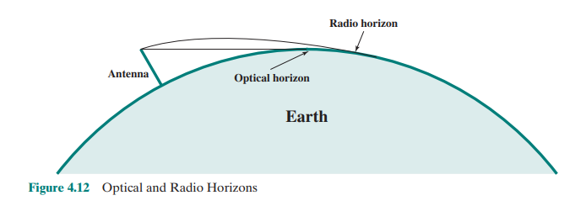

moving through a medium in which the index of refraction gradually changes. Under normal propagation conditions, the refractive index of the atmosphere decreases with height so that radio waves travel more slowly near the ground than at higher altitudes. The result is a slight bending of the radio waves toward the Earth.
Optical and Radio Line of Sight The term optical line of sight refers to the straight-line propagation of light waves; the term radio line of sight, or effective line of sight, refers to the propagation of radio waves bent by the curvature of the earth. With no intervening obstacles, the optical LOS can be expressed as
d = 3.571h
where d is the distance between an antenna and the horizon in kilometers and h is the antenna height in meters. The radio LOS to the horizon is expressed as (Figure 4.12)
d = 3.571Kh
where K is an adjustment factor to account for the refraction. A good rule of thumb is K = 4/3. Thus, the maximum distance between two antennas for LOS propagation is 3.571Kh1 + 1Kh2, where h1 and h2 are the heights of the two antennas.
Line-of-Sight Transmission
Section 3.3 discusses various transmission impairments common to both guided and wireless transmission. In this section, we extend the discussion to examine some impairments specific to wireless line-of-sight transmission.
Free Space Loss
For any type of wireless communication the signal disperses with distance. Therefore, an antenna with a fixed area receives less signal power the farther it is from the transmitting antenna. For satellite communication this is the primary mode of signal loss. Even if no other sources of attenuation or impairment are assumed, a transmitted signal attenuates over distance because the signal is being spread over a larger and larger area. This form of attenuation is known as free space loss, which can be expressed in terms of the ratio of the radiated power Pt to the power Pr received by the antenna or, in decibels, by taking 10 times the log of that ratio. For the ideal isotropic antenna, free space loss is
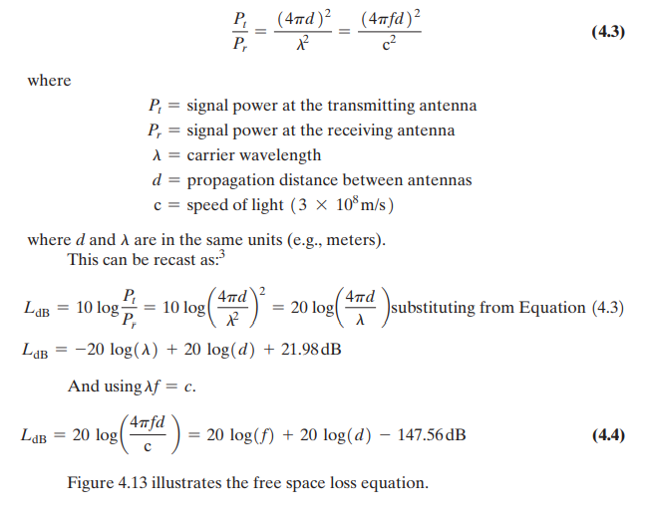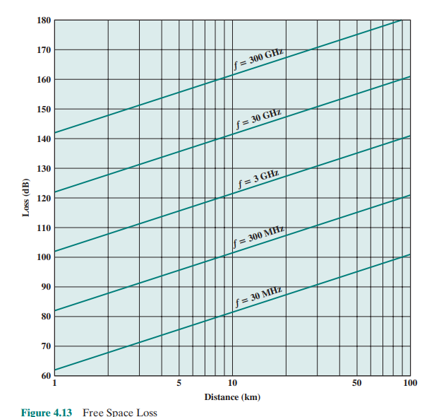
For other antennas, we must take into account the gain of the antenna, which yields the following free space loss equation:
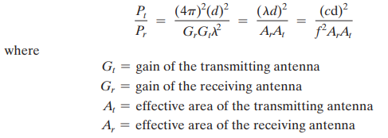
The third fraction is derived from the second fraction using the relationship between antenna gain and effective area defined in Equation (4.1). We can recast the loss equation as:
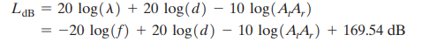
Thus, for the same antenna dimensions and separation, the longer the carrier wavelength (lower the carrier frequency f), the higher is the free space path loss. It is interesting to compare Equations (4.4) and (4.5). Equation (4.4) indicates that as the frequency increases, the free space loss also increases, which would suggest that at higher frequencies, losses become more burdensome. However, Equation (4.5) shows that we can easily compensate for this increased loss with antenna gains. In fact other factors remaining constant, there is a net gain at higher frequencies. Equation (4.4) shows that at a fixed distance an increase in frequency results in an increased loss measured by 20 log(f). However, if we take into account antenna gain and fix antenna area, then the change in loss is measured by −20 log(f); that is, there is actually a decrease in loss at higher frequencies.

